E-mail: sdfasiullah924@gmail.com

Contact: 7097450534

**FoodBox.com**

**RESTful Spring Boot E-Commerce portal with JPA Data Base & Front-End with Angular v8:**

In this project, I developed Restful Spring Boot E-Commerce portal named FoodBox.com that uses internal memory database i.e., Spring H2 Data Base to store all the information about the food items, users who purchased it & this information can be fetched up by date & Customer name as well.

I developed the Front end of this using Angular v8 as a JavaScript Framework.

Here, Admin can manage all the food items by categorizing them as food ID, food name, availability at the store & food price.

Admin can see the food ordered list filtered by date & category.

**Tools:**

1. Agile-Scrum-Jira
2. Spring Tool Suite | 4
3. Spring boot initializer
4. Angular version 8.3.19
5. Postman
6. Git
7. GitHub

**Steps for Execution:**

1. Clone the project from the repository, FoodBox.com

GitHub Link:

As I have developed the RESTful API, it can also be verified on postman tool.

1. I have used SWAGGER in my spring boot RESTful API project so that the project documentation can be well understood and can easily be verified.
2. URL for H2 Database: **http://localhost:8080/h2**
3. URL for the SWAGGER documentation:

[**https://localhost:8080/swagger-ui.html**](https://localhost:8080/swagger-ui.html)

1. All the endpoints and example data will be present in that link and an option to try it out, Put the data into which will be in JSON format and simply try it out.

**Headers End-Point**

1. **To add or update food items i.e.,**

**Post/Put food items------------------------------------ /food**

1. **Get/Delete food by Id---------------------------------- /food/{id}**
2. **To view all food items---------------------------------- /foods**
3. **Post/Put to add & update user ---------------------- /user**
4. **Get to get all users info. ----------------------------- /users**
5. **Get Users by:**
6. **Get users by userId ------------------------- /user/{userId}**
7. **Get users by username-------------------- /user/username/{userName}**
8. **Get users by userAge ---------------------- /user/userAge/{userAge}**
9. **Get/Delete users by id --------------------------------/user/{userId}**
10. **Admin Registration-------------------------------------/registration**
11. **Admin Login----------------------------------------------/login**

**Screen Shots of the output result:**

**UI of the above Application with Angular v8**

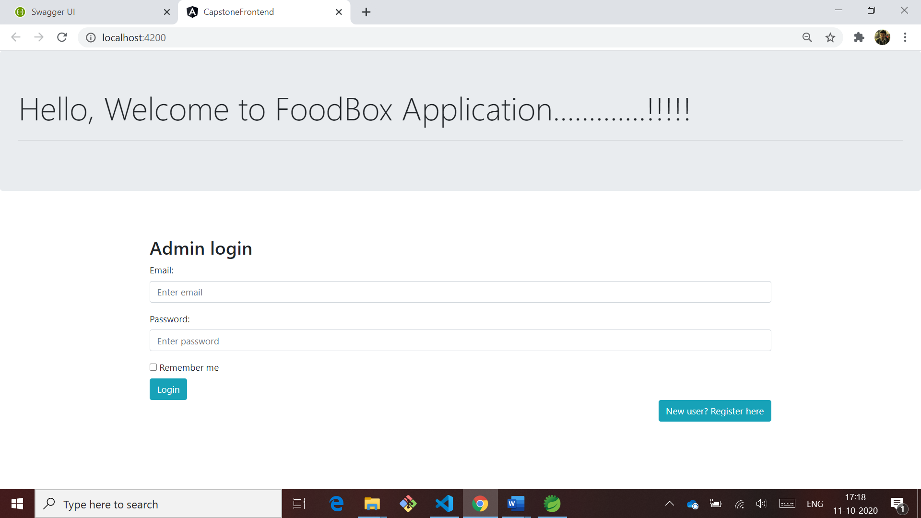

**If you do not specify any Email ID and password or entered which is not registered then it will display as shown below**

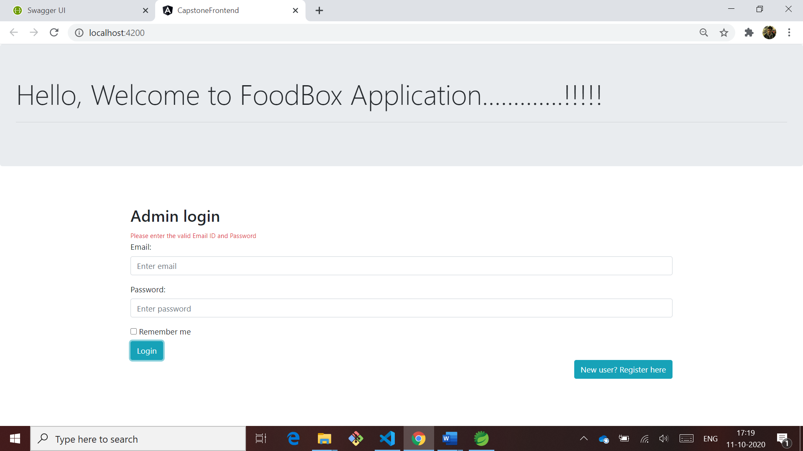

**2. To login, Admin needs to register first**

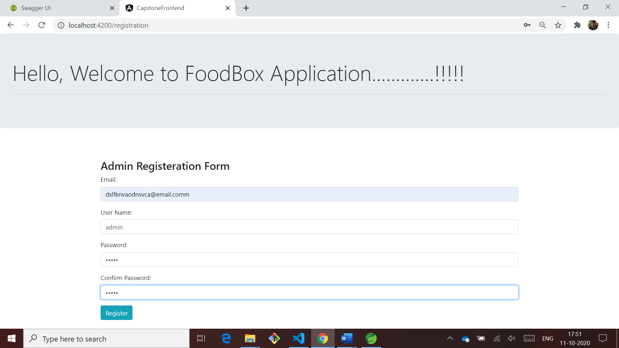

**Once you click on register, you will be navigated to login page**

**After logging in, Home page of the application is displayed where admin can perform all the operations like Add, Update, Delete, View as shown below,**

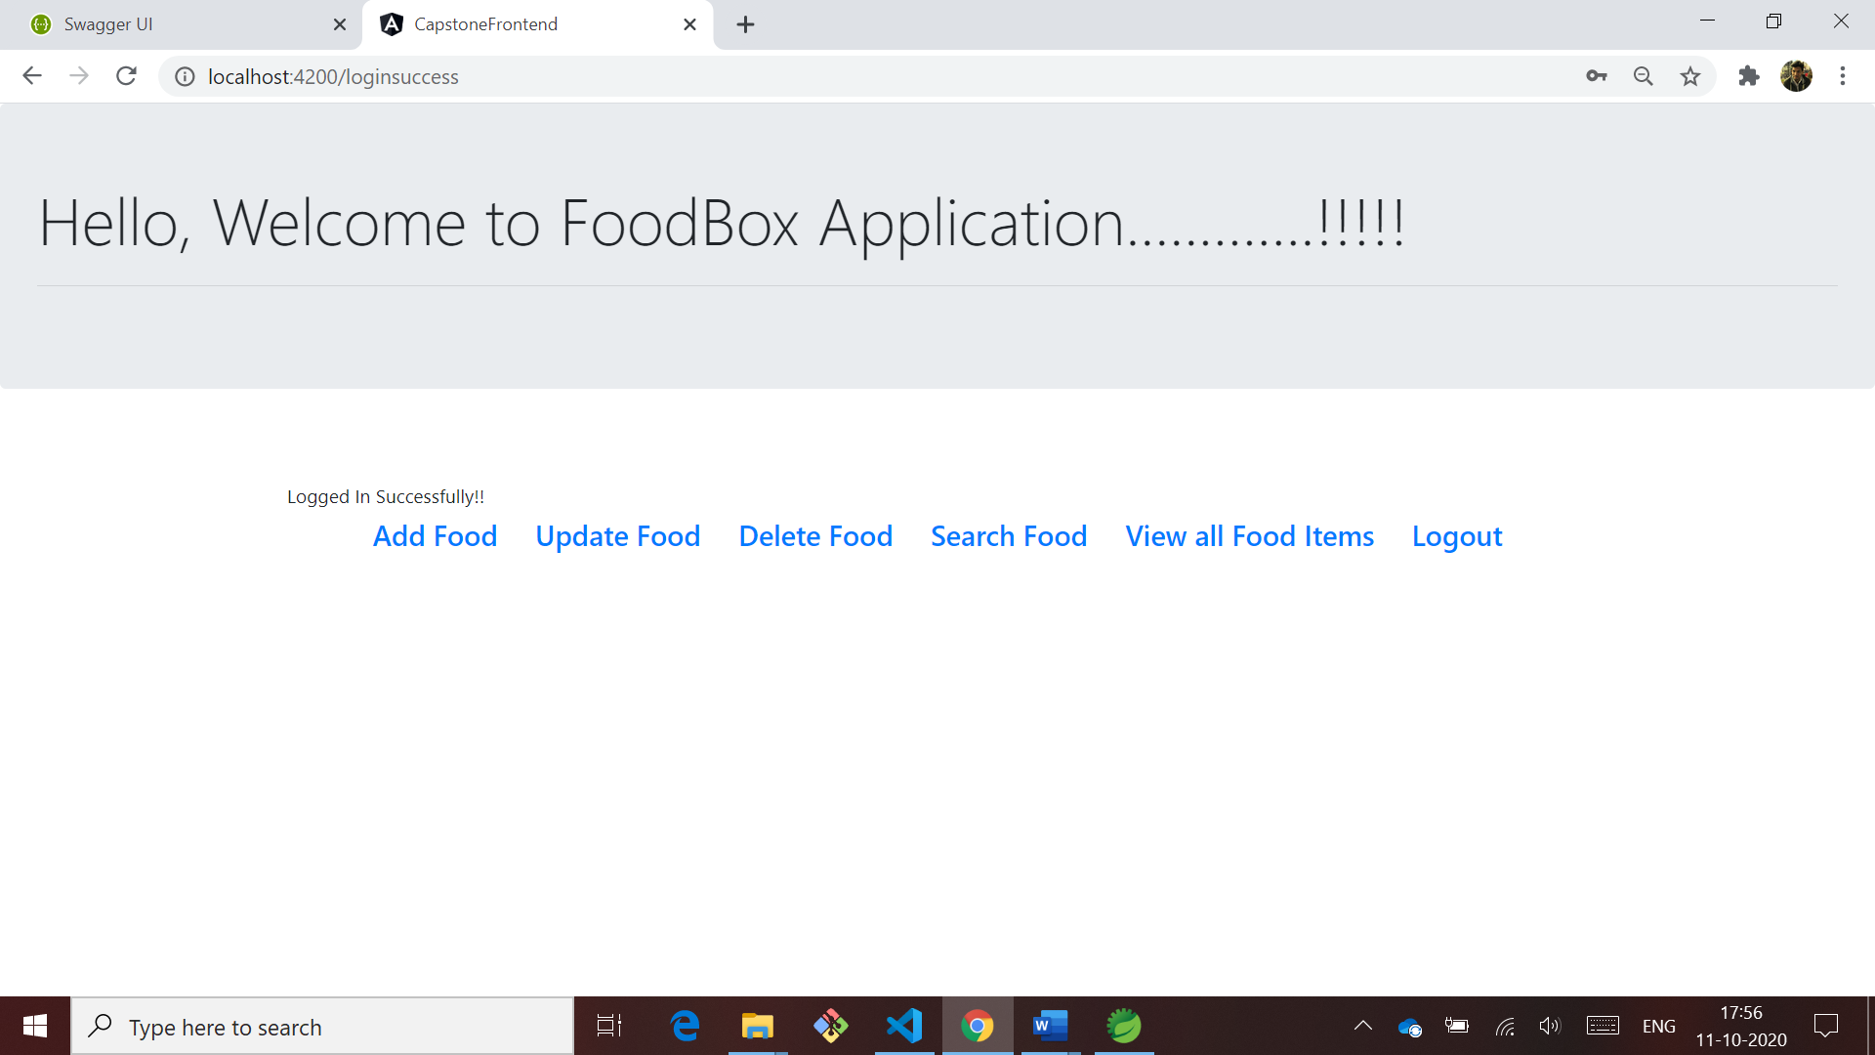

**3. Add Food**

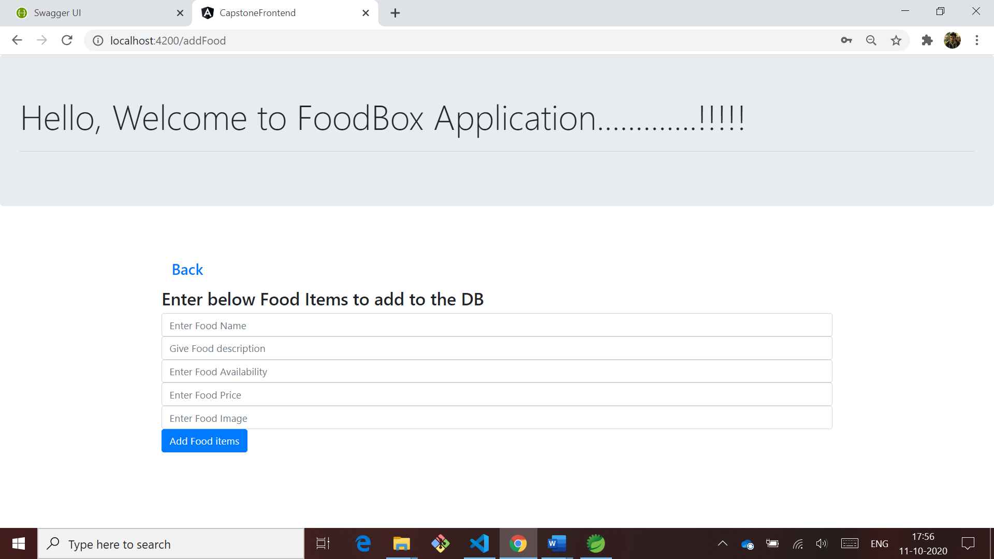

**4. Update Food**

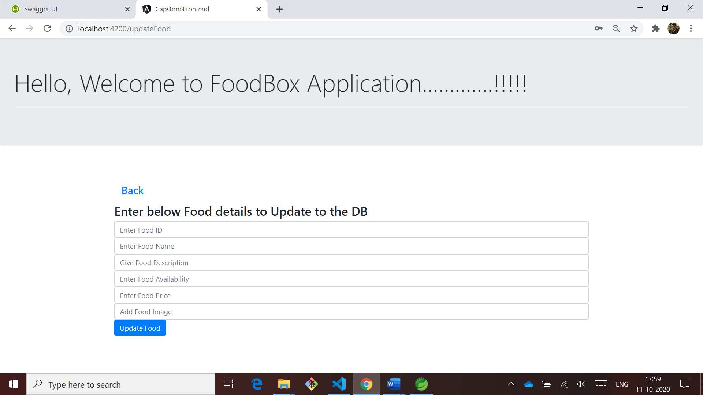

1. **Delete Food, to delete any food item admin needs to enter it’s ID**

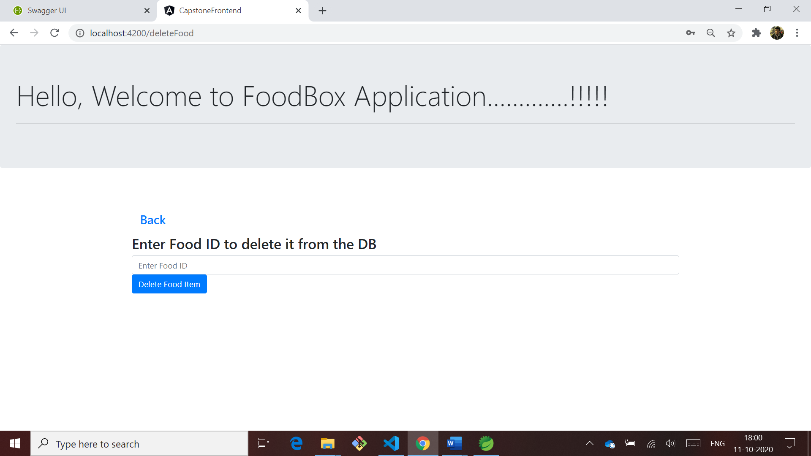

1. **Search Food**

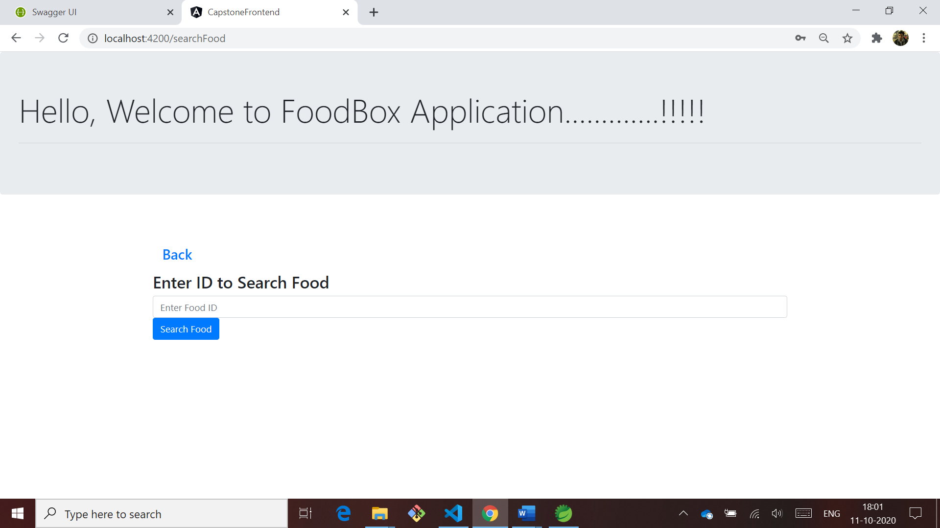

1. **View All Food Items**

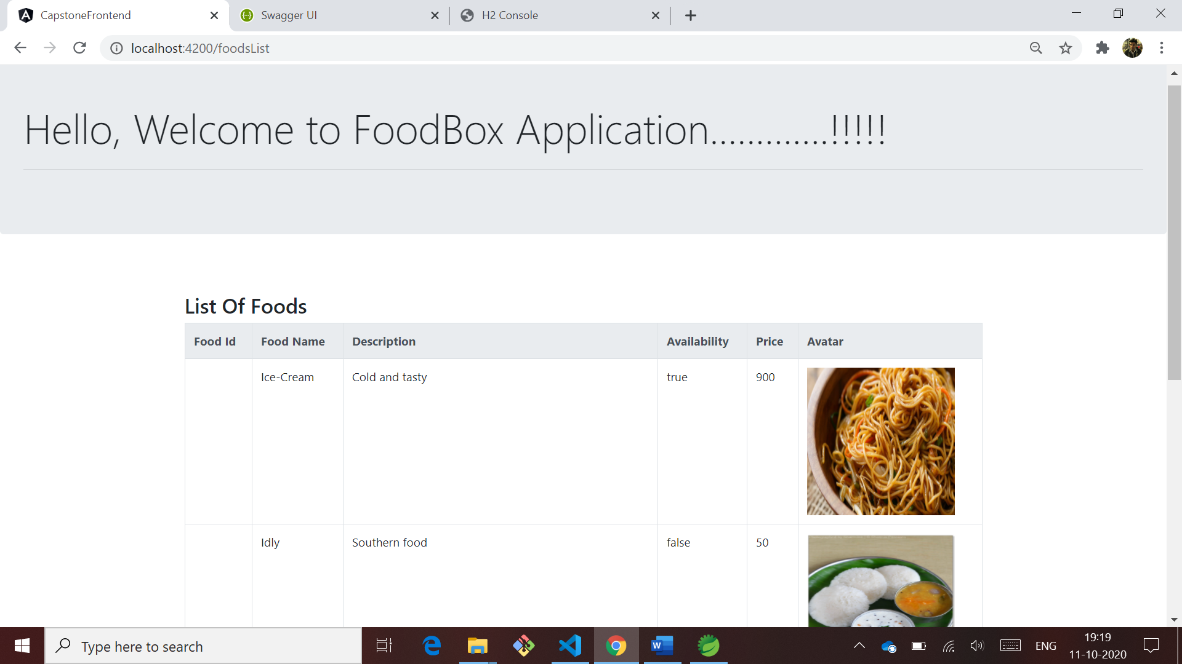

**Cont.,**

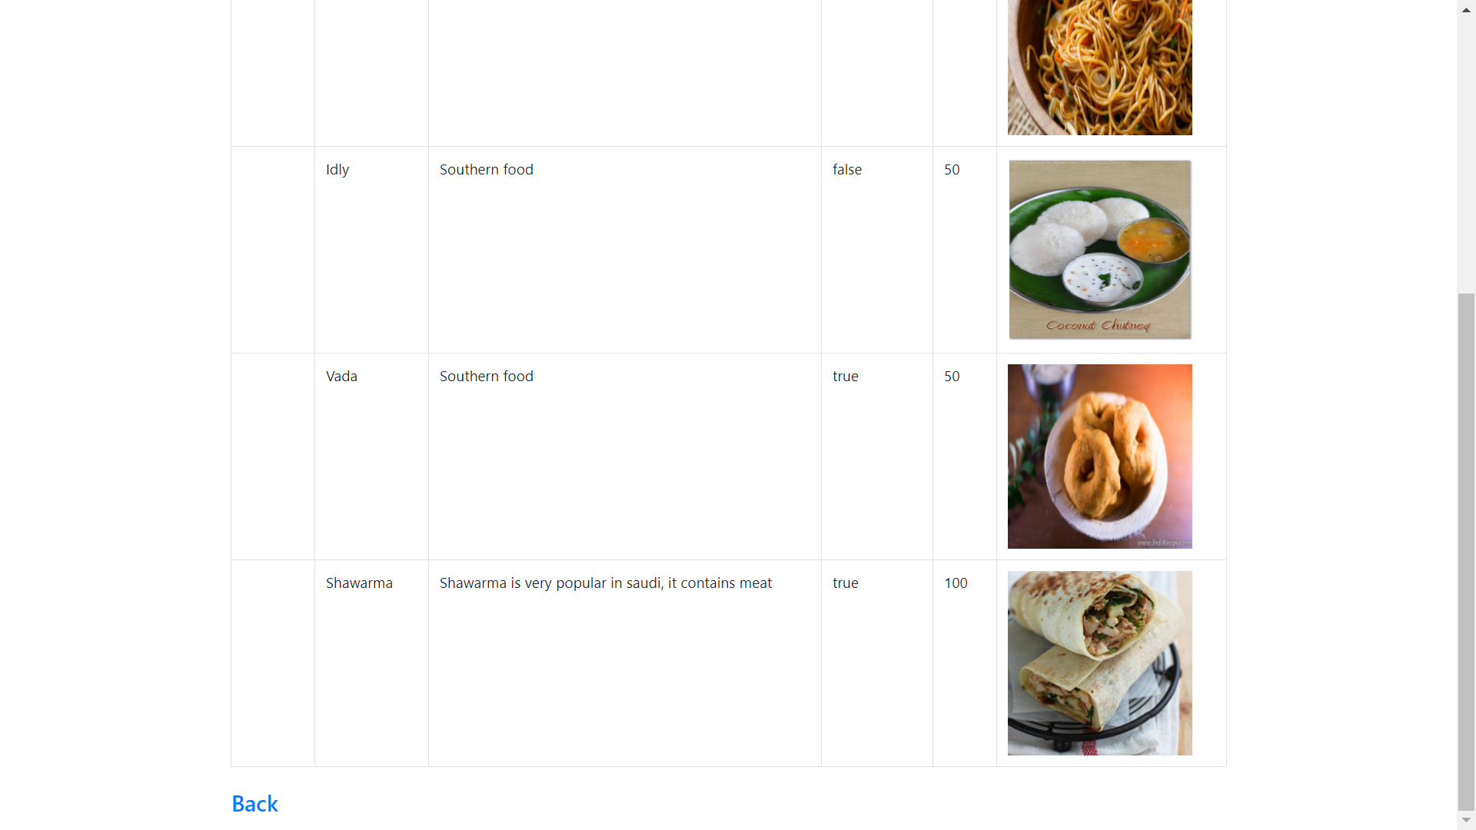

**Cont.,**

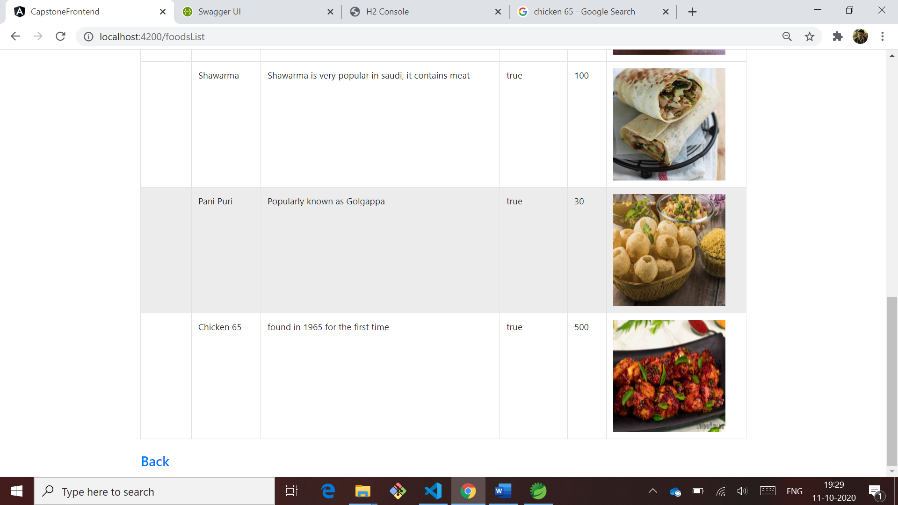

**I implemented Swagger also,**

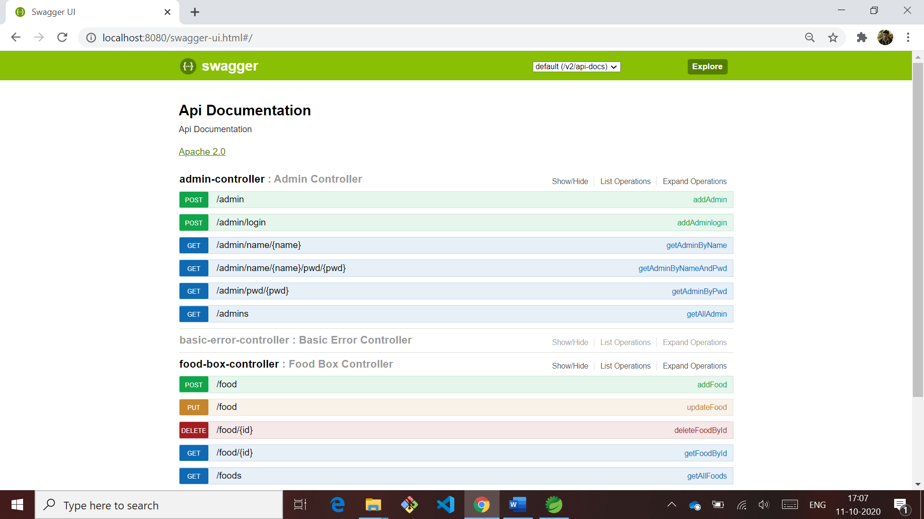

**Registering Admin below**

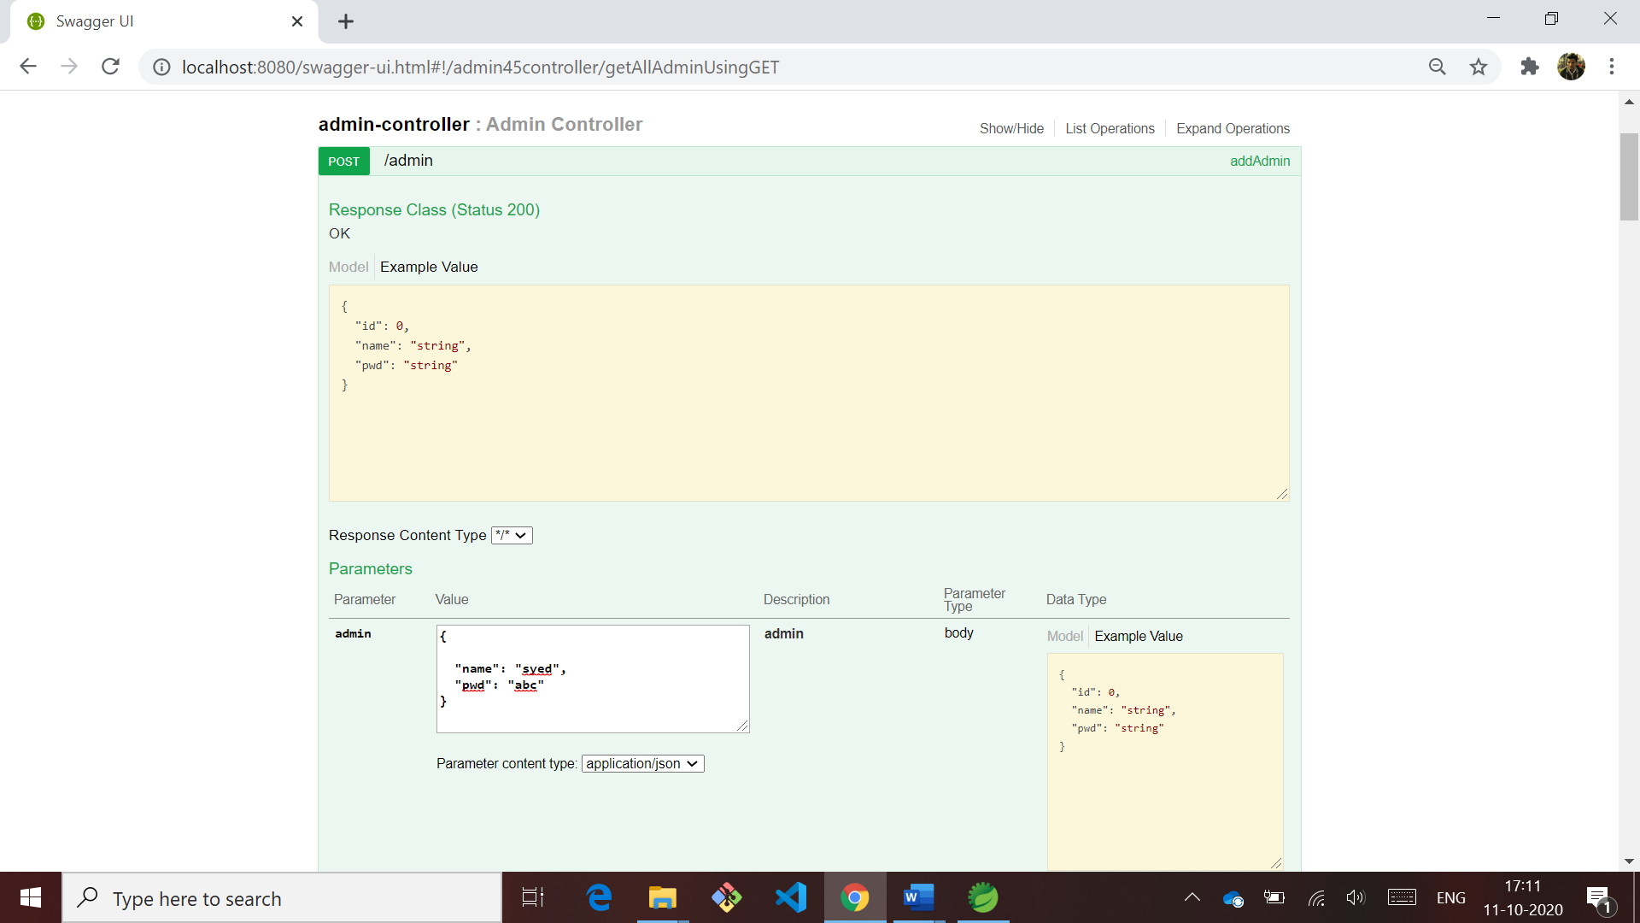

**Corresponding response body**

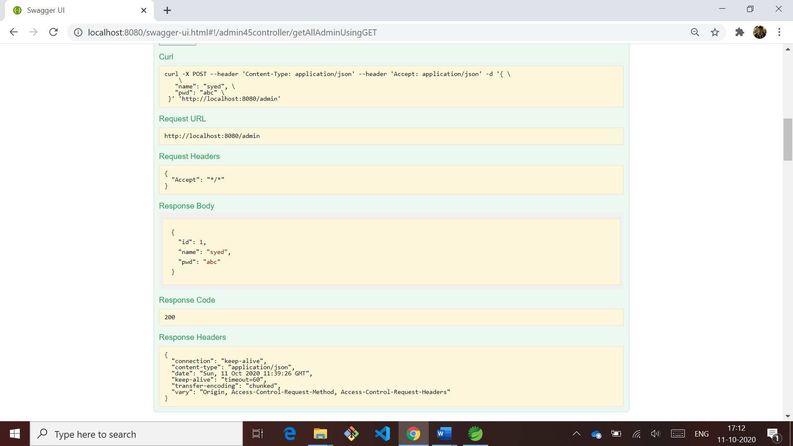

**Get method to see admin details**

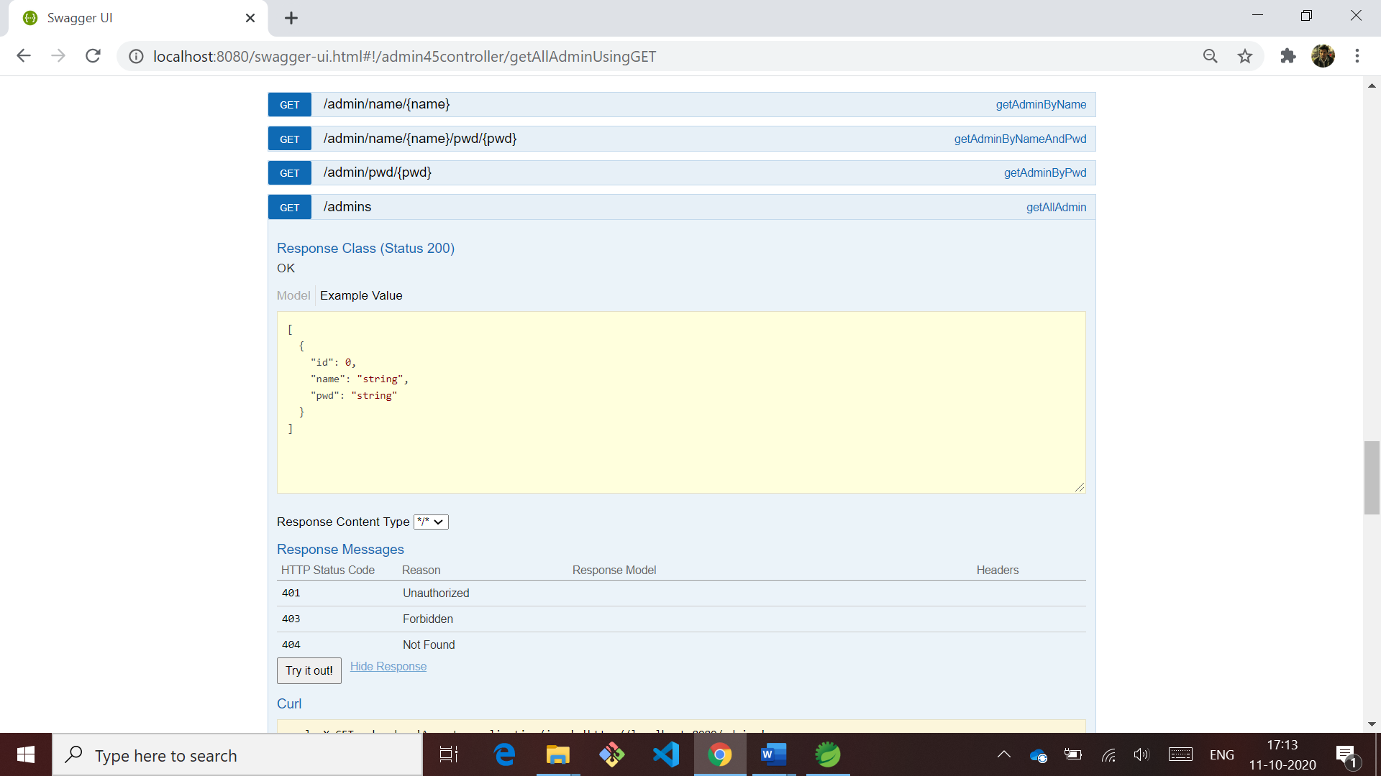

**It says only one admin is registered until now as shown below**



**Image contains all the food items I added to the H2 database**

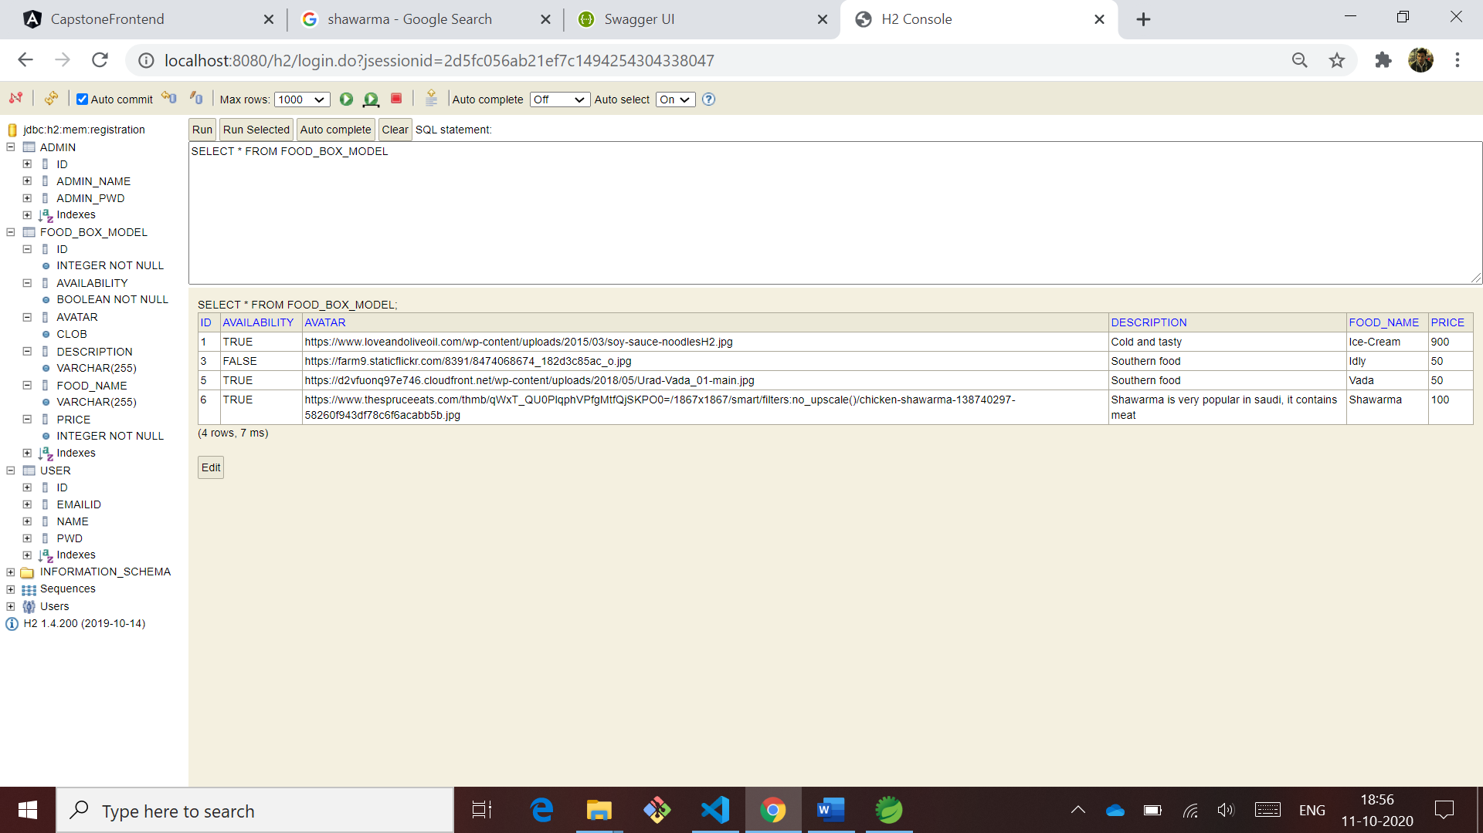

**Below image shows that there are 3 Admins registered to the app. to handle foodbox.com**

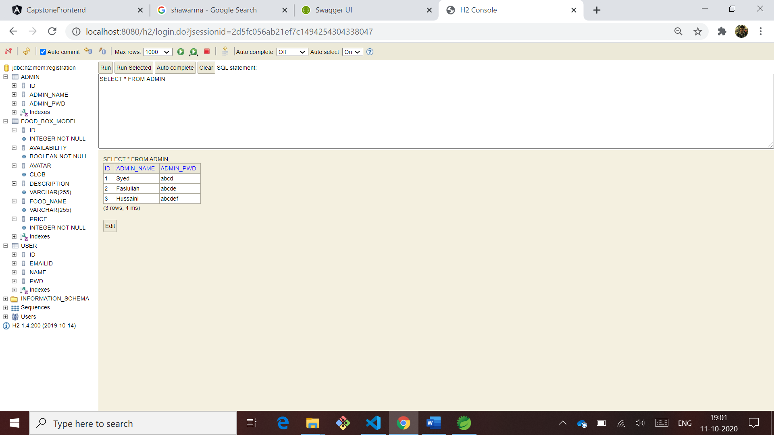

**Image below shows that there are 6 users logged in to FoodBox.com**

